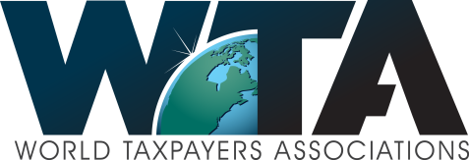
Letter from the Chairman, no 9
Stockholm April 27th 2015

Dear members and friends of the World Taxpayers Associations!
The United Nations – a role model for transparency and good internal control? Unfortunately not! David Williams of the Taxpayers Protection Alliance has launched a petition around the UN lead celebration of Press Freedom Day May 3rd. He notes with an example that the UN is not always in practice a leader for press freedom and transparency and would like your support for their petition, which is added at the end of my letter. If you want to support this initiative, send an e-mail to David at davidwilliams@protectingtaxpayers.org
- WTA – reaching the millions
- We had a question as to how many persons our “members members” would add up to. This is not as easy to answer as one would think – we generally count as members those of course who have paid their member fee or donated in the last year or two. Some organizations can be very important in the local situation without searching to have a large number of members. But based on this kind of calculation we can safely support a figure of over 2 million. If we start to add Internet supported like the 350.000 in France or the large number in Korea it would be more like 3 million! What a great network for activities, sharing of knowledge and successes – and friendships! So we are eager to hear more from you all. WTA wants to be a great reference base also, strengthening your local platform and activities.

Europe – on the way up?
The Greek crises seem to be getting worse and there are great difficulties in many places – the Ukraine and the refugee pressure on Italy, just to mention two.
- Financially in total there seems to be a budding optimism. One sign being improvement in car sales of more than 10% over all last year – and in Spain even over 40%. The large picture everywhere seems to be of change and insecurity. There are elections in several countries which might change the political landscape. Finland just had a general election leading to a new party combination governing and Great Britain has one May 7th.

Governments spending more than the taxes they take in
This has been the story in almost all countries. So also in Sweden where in the 1980’s we had to have one devaluations after the other as the parliament would add more to expenses and cut back on unpopular taxes. The effect was a disappearance of jobs and much speculation.
- In the major tax reform in the early 1990’s, in which the Swedish Tax payers had a major role, a much more stable system was established – including also a drastic lowering of the maximum marginal tax rate from over 80% to 50%. And the establishment of a tax surplus of 1% over an economic cycle. This was achieved over the party bounderies and has held and led to a stable economy and with a debt to GNP declining to under 40%.
- It is thus also of importance not only to look at the tax share of GNP but also the share of tax spending relative to GNP. The OECD figures from 2011 show the following relationships in declining order:
- Denmark 57.7%, France 55.9%, Finland 55.3%, Belgium 53.5%, Greece 51.8 %. Sweden 51.5%, Austria 50.8%, Slovenia 50.8%, Netherlands 50.1%, Hungary 50.1%, Italy 49.9%.
- Not surprisingly the French debt clock is running at record speed – the debt about to reach 32.000 € per inhabitant! See under www.contribuables.org From their web page you can also reach their “TV channel” – or go directly to https://www.youtube.com/v/EIu5Xyd9WBM
- More details on government spending under this link:
https://data.oecd.org/gga/general-government-spending.htm
- Ghana – Taxpayers’ Alliance take a stand on corruption

- The NDC government elected on a stand against corruption and promising good governance is proving as corrupt as the predecessors. An estimate is that the level of corruption is about the same as bail out support money from the IMF. The Taxpayers’ Alliance Ghana is taking a stand on this publicizing estimated levels of corruption in different departments. The program to create jobs for 100.000 young people is the worst forcing the government to re-organize this effort.

Members section of the WTA Web Page
We hope you have had a chance to visit the members section of our new website. We plan to have this section as a real platform for know-how and communication for all the members. We are keen to have your suggestions for additions, news and views.
- There is a very simple login at the start, but from around June 1st, it will be open to members only with individual passwords.
- To log in now just use as both user and password: wta2015
And please post your organization’s activity on the member’s blog, which is only accessible with Members Access. To post your news on the members section, please go here:
http://worldtaxpayers.org/members-update/
Here the password is just: wta

Finally – a philosophical piece -

why do people work for you?

Most people would answer –well of course to make money! This might be the major factor in some cases and countries, but research shows a different list of priorities than expected:
- Most important was the company – the image, the product etc. That is why IKEA comes out tops almost every year on the list where young people want to work!
- The boss – your employees work for YOU! Worth to remember
- The tasks – the job itself. Is it interesting enough? Does flexibility give a chance to grow and learn?
- The colleges – those you work with might not be your best friends, but certainly some of the persons you see the most of! Relationships and friendships are important.
- Making money – fifth on the list. Not without importance, but aspects like those above might mean your employee might be happier where he or she works, without moving to another job for a few dollars more!

Staffan
- PS – Do log in to your members section in www.worldtaxpayers.org – just write wta2015 as both user and password!
- 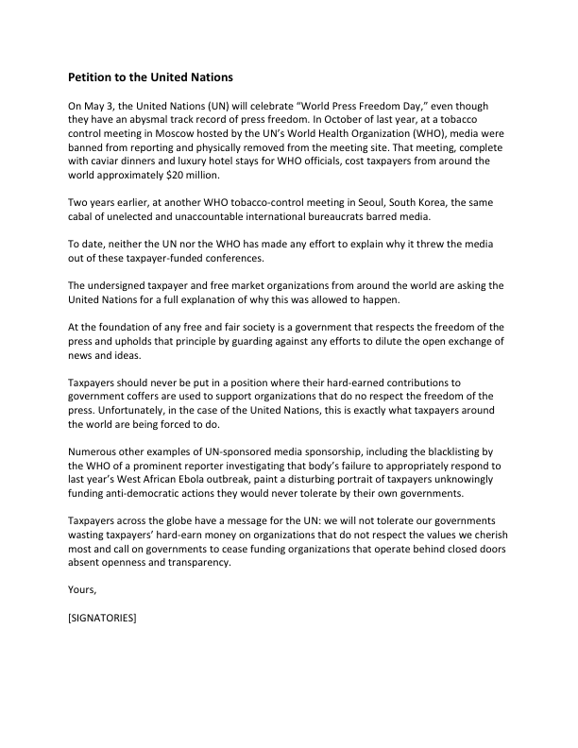

Staffan Wennberg
Chairman World Taxpayers Associations
staffan.wennberg@worldtaxpayers.org
Phone+ 46 708 15 04 95

